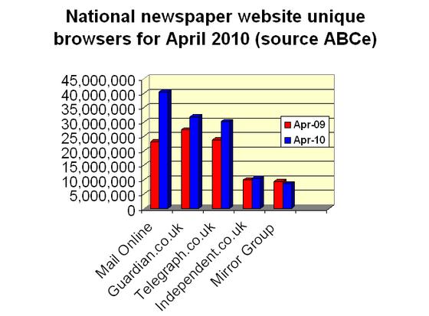
(每日獨立瀏覽者數、每月獨立瀏覽者數、年同比百分率變化)
- 《郵報》(Mail Online): 2,366,495 - 40,500,667 + 74%
- 《衛報》(Guardian.co.uk): 1,837,331 - 31,900,127 + 17%
- 《每日電訊報》(Telegraph.co.uk): 1,583,305 – 30,227,486 + 27%
- 《鏡報集團》(Mirror Group): 441,768 – 9,329,485 + 9%
- 《獨立報》(The Independent): 455,255 – 9,871,286 -5%

